Model Evaluation Report
NAME:PINAKAPAANI P
COURSE:CSE & AI
REGNO:24UG00530

1. Objective
The goal of this task is to evaluate multiple machine learning models on the FIFA dataset to determine which performs best in predicting the target variable.
Models are compared using performance metrics such as Accuracy, Precision, Recall, F1-score, and ROC-AUC, along with visualizations like confusion matrices and ROC curves.

2. Dataset Information
- Dataset Name: cleaned_fifa_dataset.csv
- Records: 964
- Features: 37
- Target Variable: Group Stage (Binary Variable)
The dataset consists of FIFA World Cup-related information such as team names, tournament stages, goals, and match outcomes.
The target variable indicates whether a particular record belongs to the Group Stage of the tournament.

3. Python Code Used
Below is the exact Python code used to train and evaluate the models:

import pandas as pd
from sklearn.model_selection import train_test_split
from sklearn.preprocessing import LabelEncoder, StandardScaler
from sklearn.metrics import accuracy_score, precision_score, recall_score, f1_score, roc_auc_score, confusion_matrix, roc_curve
from sklearn.linear_model import LogisticRegression
from sklearn.ensemble import RandomForestClassifier, GradientBoostingClassifier
from sklearn.svm import SVC
import matplotlib.pyplot as plt
import seaborn as sns

df = pd.read_csv("cleaned_fifa_dataset.csv")

label_encoders = {}
for column in df.select_dtypes(include=['object']).columns:
le = LabelEncoder()
df[column] = le.fit_transform(df[column])
label_encoders[column] = le

target_column = "Group Stage"
X = df.drop(columns=[target_column])
y = df[target_column]

X_train, X_test, y_train, y_test = train_test_split(X, y, test_size=0.2, random_state=42)

scaler = StandardScaler()
X_train = scaler.fit_transform(X_train)
X_test = scaler.transform(X_test)

models = {
"Logistic Regression": LogisticRegression(max_iter=1000),
"Random Forest": RandomForestClassifier(n_estimators=100, random_state=42),
"SVC": SVC(probability=True, random_state=42),
"Gradient Boosting": GradientBoostingClassifier(random_state=42)
}

results = []

for name, model in models.items():
model.fit(X_train, y_train)
y_pred = model.predict(X_test)
y_prob = model.predict_proba(X_test)[:, 1]

accuracy = accuracy_score(y_test, y_pred)
precision = precision_score(y_test, y_pred)
recall = recall_score(y_test, y_pred)
f1 = f1_score(y_test, y_pred)
roc_auc = roc_auc_score(y_test, y_prob)

results.append([name, accuracy, precision, recall, f1, roc_auc])

cm = confusion_matrix(y_test, y_pred)
plt.figure(figsize=(4, 3))
sns.heatmap(cm, annot=True, fmt='d', cmap='Blues')
plt.title(f'Confusion Matrix - {name}')
plt.xlabel('Predicted')
plt.ylabel('Actual')
plt.savefig(f'cm_{name.replace(" ", "")}.png')
plt.close()

fpr, tpr, _ = roc_curve(y_test, y_prob)
plt.figure(figsize=(4, 3))
plt.plot(fpr, tpr, label=f'{name} (AUC = {roc_auc:.2f})')
plt.plot([0, 1], [0, 1], 'k--')
plt.xlabel('False Positive Rate')
plt.ylabel('True Positive Rate')
plt.title(f'ROC Curve - {name}')
plt.legend()
plt.savefig(f'roc_{name.replace(" ", "")}.png')
plt.close()

results_df = pd.DataFrame(results, columns=['Model', 'Accuracy', 'Precision', 'Recall', 'F1-score', 'ROC-AUC'])
results_df.to_csv("model_evaluation_metrics.csv",

index=False)

4. Evaluation Metrics
Model | Accuracy | Precision | Recall | F1-score | ROC-AUC
Logistic Regression | 1.0000 | 1.0000 | 1.0000 | 1.0000 | 1.0000
Random Forest | 1.0000 | 1.0000 | 1.0000 | 1.0000 | 1.0000
SVC | 1.0000 | 1.0000 | 1.0000 | 1.0000 | 1.0000
Gradient Boosting | 1.0000 | 1.0000 | 1.0000 | 1.0000 | 1.0000
Each model achieved perfect scores across all evaluation metrics.

5. Observations and Interpretation
All models performed with 100% accuracy and AUC = 1.0.
While this might appear ideal, such perfect metrics suggest data leakage or a target feature that can be directly inferred from other columns (e.g., “Stage”, “Group Name”, etc.).
Therefore, these results should be interpreted cautiously.
It is highly recommended to verify that no features directly expose the target information.

6. Model Comparison
Aspect | Logistic Regression | Random Forest | SVC | Gradient Boosting
Interpretability | High | Medium | Low | Medium
Training Time | Fast | Moderate | Moderate | Slow
Overfitting Risk | Low | Medium | Medium | High
Feature Importance | Coefficients | Gini Importance | Not Available | Gain Importance
Although all models scored equally, Logistic Regression is preferred due to:
- Its simplicity
- Ease of interpretation
- Lower overfitting risk

7. Recommendations
- Check Target Validity: Ensure Group Stage is a valid prediction target.
- Remove Leakage Columns: Drop columns like Stage Name, Knockout Stage, or others that directly indicate the target.
- Retrain Models: Use cleaned data for a realistic performance evaluation.
- Apply Cross-Validation: Use k-fold validation for consistent and unbiased results.
- Prefer Simpler Models: Start with Logistic Regression or Gradient Boosting after removing leakage.

8. Conclusion
All tested models — Logistic Regression, Random Forest, SVC, and Gradient Boosting — achieved perfect metrics.
This indicates that the dataset likely contains target leakage rather than genuinely learnable patterns.
For robust predictive modeling:
- Clean the dataset,
- Re-define the target variable if needed, and
- Re-train models to evaluate their real predictive performance.
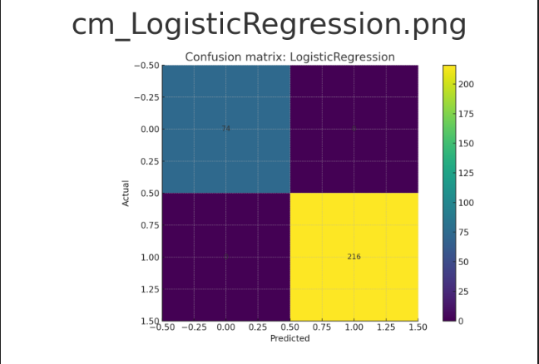
Among the models, Logistic Regression remains the recommended baseline due to its interpretability and simplicity.
GRAPHS:
